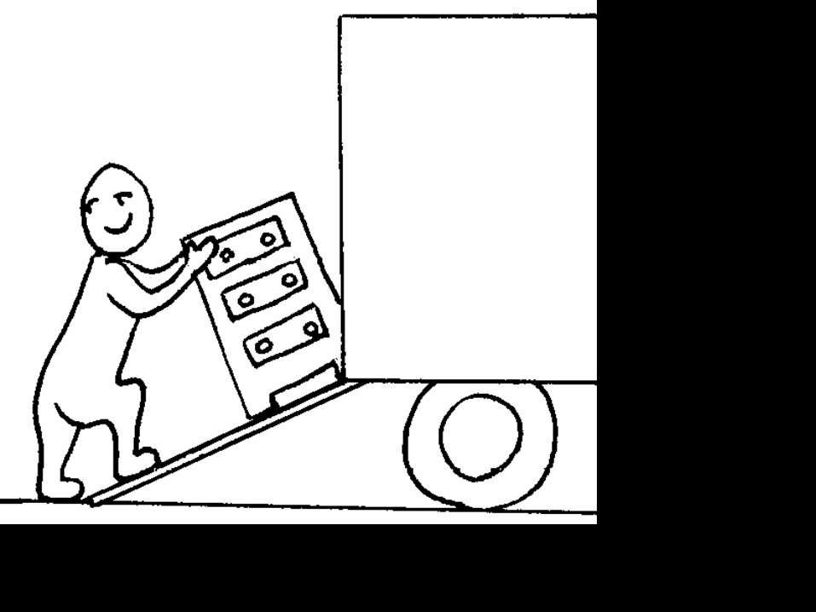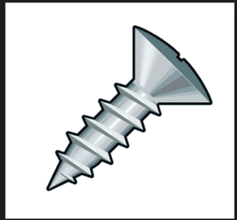Inclined Planes Mini-Assessment

Use Pearson Science p.301 - 305 TOTAL: __________

39

1. **List** three places you have used a ramp.

a. ____ **trailer, road, shopping centre, any ramp!**

b. ______________________________________________________________________________

c. ______________________________________________________________________________

(3 marks)

2. **List** three common examples of a wedge.

1. ________________ **axe, incisor teeth,** **pins, needles, doorstops, nails**
2. _____________________________________________________________________________
3. _____________________________________________________________________________

(3 marks)

3. **State** whether the following are true or false.

1. The longer the slope of a ramp for a certain height, the greater its mechanical advantage.

_______ **T** _______

1. A screw with a small pitch corresponds to a steep inclined plane.

________ **F** ________

1. A screw with a small pitch requires fewer turns to be inserted into a piece of wood than a screw with a large pitch.

________ **F** ________

1. A wedge changes the direction of a force by 90o and increases its size.

_________ **T** _______ (4 marks)

4. **State** an example of a type of screw that cuts through a:

a) solid __________________ **wood screw**

b) liquid _________________ **boat propeller**

c) gas ____________________ **aircraft propeller**

(3 marks)

5. **Recall** five devices that can be produced by flaking.

__________ **spearhead, chisels, axes, saws, knives**

_____________________________________________________________________________________

_____________________________________________________________________________________

(5 marks)

6. **Recall** one name for a spear thrower ______ **woomera**

(1 mark)

7. You have been given the job of building a road up the following hill.

1. **Draw** in the road that would be shortest but hardest to walk up.
2. **Draw** in a road that would be long but easy to walk up.

(2 marks)

8. **Describe** how a stone is flaked __________________________________________________

**A block of stone (called a core), is struck with a hammer stone**

**(usually a pebble), to chip off a sharp piece of stone, called a flake.**

(2 marks)

9. **Explain** why stone rich in silica is suitable to use in creating stone tools

**They are hard but brittle.**

______________________________________________________________________________________

______________________________________________________________________________________

(1 mark)

10. **Identify** which type of simple machine (inclined plane, wedge or screw) is described by these devices:

1. corkscrew _______________ **screw**
2. axe _______________________ **wedge**
3. electric fan _______________ **screw**
4. car park ramp ___________ **inclined plane**
5. chisel _____________________ **wedge**
6. escalator _________________ **inclined plane**

(6 marks)

11. Mechanical advantage is equal to length of slope

height of ramp

**Calculate** the mechanical advantage of the following ramps:

|  |  |  |
| --- | --- | --- |
| **Length of Slope**  **(m)** | **Height of Ramp**  **(m)** | **Mechanical**  **Advantage** |
| 15 | 3 | **5** |
| 50 | 25 | **2** |
| 12 | 2 | **6** |
| 20 | 5 | **4** |
| 240 | 30 | **8** |

(5 marks)

12. Use a piece of scrap paper to cut out a gentle slope and a steep slope (see p.304 SB) and wrap them around a pencil.

Gentle Slope

Steep Slope

When you wrapped them around a pencil and produced a “screw”, was the thread spread out or tight together?

1. Gentle slope ________________________ **tight**
2. Steep slope ________________________ **spread**

(2 marks)

13. **Draw** an axe head and show how it is two inclined planes.

(2 marks)